Assignment 5: Chatbot for Customer Interaction

CODE:
<!DOCTYPE html>
<html>
<head>
<title>Customer Support Chatbot</title>
<style>
body {
font-family: Arial, sans-serif;
background: linear-gradient(135deg, #667eea 0%, #764ba2 100%);
display: flex;
justify-content: center;
align-items: center;
height: 100vh;
margin: 0;
}
.chat-container {
width: 400px;
height: 600px;
background: white;
border-radius: 10px;
box-shadow: 0 10px 30px rgba(0,0,0,0.3);
display: flex;
flex-direction: column;
}
.chat-header {
background: #2196F3;
color: white;
padding: 20px;
border-radius: 10px 10px 0 0;
text-align: center;
}
.chat-box {
flex: 1;
padding: 20px;
overflow-y: auto;
background: #f5f5f5;
}
.message {
margin: 10px 0;
padding: 10px 15px;
border-radius: 18px;
max-width: 70%;
word-wrap: break-word;
}
.bot-message {
background: #e3f2fd;
float: left;
clear: both;
}
.user-message {
background: #2196F3;
color: white;
float: right;
clear: both;
}
.input-area {
display: flex;
padding: 15px;
border-top: 1px solid #ddd;
}
#userInput {
flex: 1;
padding: 10px;
border: 1px solid #ddd;
border-radius: 20px;
outline: none;
font-size: 14px;
}
button {
margin-left: 10px;
padding: 10px 20px;
background: #2196F3;
color: white;
border: none;
border-radius: 20px;
cursor: pointer;
}
button:hover {
background: #0b7dda;
}
.options {
margin: 10px 0;
}
.option-btn {
display: block;
margin: 5px 0;
padding: 8px 15px;
background: #4CAF50;
color: white;
border: none;
border-radius: 15px;
cursor: pointer;
width: 100%;
text-align: left;
}
.option-btn:hover {
background: #45a049;
}
.clear {
clear: both;
}
</style>
</head>
<body>
<div class="chat-container">
<div class="chat-header">
<h2>🤖 Customer Support Bot</h2>
<p style="margin:0; font-size:12px;">Online - Ready to help!</p>
</div>

<div class="chat-box" id="chatBox"></div>

<div class="input-area">
<input type="text" id="userInput" placeholder="Type your message..."
onkeypress="if(event.key==='Enter') sendMessage()">
<button onclick="sendMessage()">Send</button>
</div>
</div>

<script>
const knowledgeBase = {
greetings: ['hi', 'hello', 'hey', 'good morning', 'good evening'],
help: ['help', 'support', 'assist'],
products: ['product', 'products', 'items', 'what do you sell'],
pricing: ['price', 'cost', 'how much', 'pricing'],
delivery: ['delivery', 'shipping', 'ship', 'deliver'],
returns: ['return', 'refund', 'exchange'],
contact: ['contact', 'phone', 'email', 'reach'],
hours: ['hours', 'timing', 'open', 'close', 'time'],
bye: ['bye', 'goodbye', 'exit', 'quit', 'thanks', 'thank you']
};

const responses = {
greetings: "Hello! Welcome to TechStore. How can I assist you today?",
help: "I can help you with:\n• Product information\n• Pricing\n• Delivery details\n• Returns & Refunds\n• Contact information",
products: "We sell:\n• Laptops\n• Smartphones\n• Tablets\n• Accessories\nWhat would you like to know more about?",
pricing: "Our products range from $100 to $2000. Please specify which product you're interested in for exact pricing.",
delivery: "We offer:\n• Free delivery on orders above $500\n• Standard delivery: 5-7 business days\n• Express delivery: 2-3 business days ($20 extra)",
returns: "Our return policy:\n• 30-day return window\n• Full refund if unopened\n• Free return shipping\n• Exchange available",
contact: "Contact us:\n📞 Phone: 1-800-TECH-HELP\n📧 Email: support@techstore.com\n💬 Live chat: Available 24/7",
hours: "We're open:\n• Monday-Friday: 9 AM - 8 PM\n• Saturday: 10 AM - 6 PM\n• Sunday: Closed\n• Online support: 24/7",
bye: "Thank you for contacting TechStore! Have a great day! 😊",
default: "I'm not sure about that. Let me show you what I can help with."
};

function addMessage(message, isUser) {
const chatBox = document.getElementById('chatBox');
const msgDiv = document.createElement('div');
msgDiv.className = 'message ' + (isUser ? 'user-message' : 'bot-message');
msgDiv.innerHTML = message.replace(/\n/g, '<br>');
chatBox.appendChild(msgDiv);

const clear = document.createElement('div');
clear.className = 'clear';
chatBox.appendChild(clear);

chatBox.scrollTop = chatBox.scrollHeight;

// Console log
console.log((isUser ? 'User: ' : 'Bot: ') + message);
}

function showOptions() {
const chatBox = document.getElementById('chatBox');
const optionsDiv = document.createElement('div');
optionsDiv.className = 'options';

const options = [
'Products',
'Pricing',
'Delivery Info',
'Return Policy',
'Contact Us'
];

options.forEach(option => {
const btn = document.createElement('button');
btn.className = 'option-btn';
btn.textContent = '📌 ' + option;
btn.onclick = () => {
document.getElementById('userInput').value = option;
sendMessage();
};
optionsDiv.appendChild(btn);
});

chatBox.appendChild(optionsDiv);
chatBox.scrollTop = chatBox.scrollHeight;
}

function getBotResponse(userMessage) {
const msg = userMessage.toLowerCase().trim();

// Check each category
for (let category in knowledgeBase) {
if (knowledgeBase[category].some(keyword => msg.includes(keyword))) {
return responses[category];
}
}

return responses.default;
}

function sendMessage() {
const input = document.getElementById('userInput');
const message = input.value.trim();

if (message === '') return;

// Add user message
addMessage(message, true);
input.value = '';

// Get bot response
setTimeout(() => {
const response = getBotResponse(message);
addMessage(response, false);

// Show options if default response
if (response === responses.default) {
showOptions();
}
}, 500);
}

// Initialize chat
window.onload = function() {
console.log('=== Customer Support Chatbot Started ===');
addMessage('Hello! I\'m your virtual assistant. How can I help you today?', false);
showOptions();
};
</script>
</body>
</html>

OUTPUT:

=== Customer Support Chatbot Started ===
Bot: Hello! I'm your virtual assistant. How can I help you today?
User: Hi
Bot: Hello! Welcome to TechStore. How can I assist you today?
User: What products do you have?
Bot: We sell:
• Laptops
• Smartphones
• Tablets
• Accessories
What would you like to know more about?
User: pricing
Bot: Our products range from $100 to $2000. Please specify which product you're interested in for exact pricing.
User: delivery info
Bot: We offer:
• Free delivery on orders above $500
• Standard delivery: 5-7 business days
• Express delivery: 2-3 business days ($20 extra)
User: return policy
Bot: Our return policy:
• 30-day return window
• Full refund if unopened
• Free return shipping
• Exchange available
User: contact
Bot: Contact us:
📞 Phone: 1-800-TECH-HELP
📧 Email: support@techstore.com
💬 Live chat: Available 24/7
User: thanks
Bot: Thank you for contacting TechStore! Have a great day! 😊

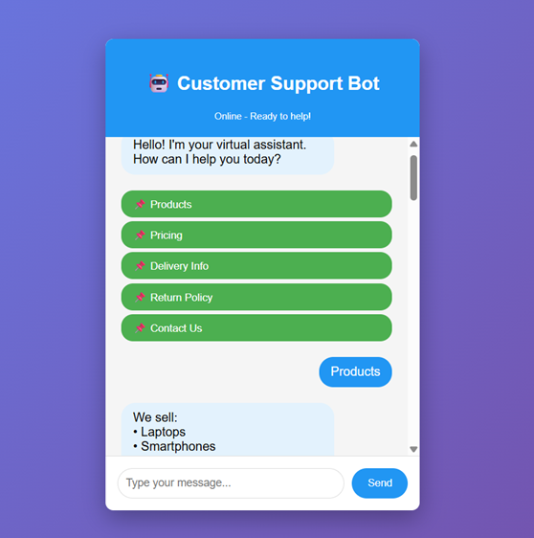
EXPLAINATION:
Pattern Matching Chatbot:
- Knowledge Base - Contains keywords for each topic
- User Input - Convert to lowercase and trim
- Keyword Matching - Check if input contains any keyword
- Response Generation - Return appropriate response
- Default Handling - Show options if no match found
Features:
- Keyword-based matching
- Multiple keyword support per category
- Quick reply buttons
- Conversation logging in console
- User-friendly interface
Flow:
User Input → Keyword Match → Response → Display
↓
No Match → Show Options

